JAVA ASSIGNMENT-5 (13/11/2018)

1)Write a java program to find the big number in given two numbers

class BigIn2
{
static void firstLast(int a,int b)
{
if(a>b)
{
System.out.println(a+" is big number");
}
else
{
System.out.println(b+" is big number");
}
}
}
class TestBig2
{
public static void main(String args[])
{
BigIn2.firstLast(5,8);
}
}

Output:
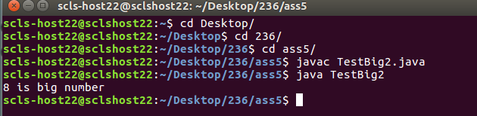

2)Write a java program to find the big number in the given three numbers

class Big
{
int a[]={10,40,30};
int max=0;
void bigNumber()
{
for(int i=0;i<3;i++)
{
if(a[i]>max)
{
max=a[i];
}
}
System.out.println(max+" is big number");
}
}
class TestBigIn3
{
public static void main(String args[])
{
Big obj=new Big();
obj.bigNumber();
}
}

Output:
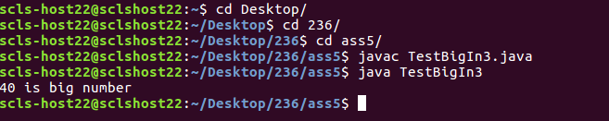

3)Write a java program to find the sum of numbers of an integer array

class Sum
{
int a[]={10,40,30};
void arraySum()
{
int sum=0;
for(int i=0;i<3;i++)
{
sum=sum+a[i];
}
System.out.println("sum is"+sum);
}
}
class TestArraySum
{
public static void main(String args[])
{
Sum obj=new Sum();
obj.arraySum();
}
}

Output:
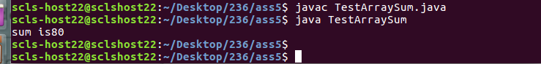

4)Write a java program to find the first element and last element of the given array

class ArrFl
{
static void firstLast()
{
int ar[]={10,50,60,70};
int index;
System.out.println("first number is "+ar[0]);
System.out.println("last number is "+ar[ar.length-1]);
}
}
class TestFL
{
public static void main(String args[])
{
ArrFl.firstLast();
}
}

Output:
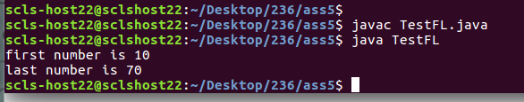

5)Write a java program to find the big number in the given array

class Test
{
int a[]={10,50,60,80,60,100,10,120};
int max=0;
void bigNum()
{
for(int i=0;i<a.length;i++)
{
if(a[i]>max)
{
max=a[i];
}
}
System.out.println(max+" is big number");
}
}
class TestFindBig
{
public static void main(String args[])
{
Test obj=new Test();
obj.bigNum();
}
}

Output:
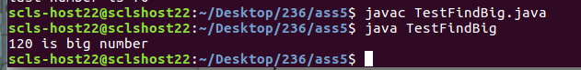

6)Write a java program to implement five arithmetic operations using switch case method.

class Arithmetic
{
static void getArth(int a,int b)
{
int choice=2;
switch(choice)
{
case 1:int c=a+b;
System.out.println(c);
break;
case 2:int d=a-b;
System.out.println(d);
break;
case 3:int e=a*b;
System.out.println(e);
break;
case 4:float f=(float)a/b;
System.out.println(f);
break;
case 5:int g=a%b;
System.out.println(g);
break;
default:System.out.println("The choice should be in between and 5");
}
}
}
class TestSwitch
{
public static void main(String args[])
{
Arithmetic.getArth(5,2);
}
}
Output:
